**Greenwood College**

**Semester One Examination, 2018**

**Question/Answer Booklet**

**MATHEMATICS APPLICATIONS**

**UNIT 1**

**Section Two:**

**Calculator-assumed**

Your name

**Time allowed for this section**

Reading time before commencing work: ten minutes

Working time for this section: one hundred minutes

**Materials required/recommended for this section**

***To be provided by the supervisor***

This Question/Answer Booklet

Formula Sheet (retained from Section One)

***To be provided by the candidate***

Standard items: pens (blue/black preferred), pencils (including coloured), sharpener,

correction fluid/tape, eraser, ruler, highlighters

Special items: drawing instruments, templates, notes on two unfolded sheets of A4 paper, and up to three calculators approved for use in the WACE examinations

**Important note to candidates**

No other items may be taken into the examination room. It is **your** responsibility to ensure that you do not have any unauthorised notes or other items of a non-personal nature in the examination room. If you have any unauthorised material with you, hand it to the supervisor **before** reading any further.

### 

**Structure of this paper**

|  |  |  |  |  |  |
| --- | --- | --- | --- | --- | --- |
| Section | Number of questions available | Number of questions to be answered | Working  time (minutes) | Marks available | Percentage of exam |
| Section One:  Calculator-free | 7 | 7 | 50 | 53 | 35 |
| Section Two:  Calculator-assumed | 12 | 12 | 100 | 97 | 65 |
|  | | | **Total** | 150 | 100 |

**Instructions to candidates**

1. The rules for the conduct of examinations are detailed in the school handbook. Sitting this examination implies that you agree to abide by these rules.

2. Write your answers in this Question/Answer Booklet.

3. You must be careful to confine your response to the specific question asked and to follow any instructions that are specified to a particular question.

4. Spare pages are included at the end of this booklet. They can be used for planning your responses and/or as additional space if required to continue an answer.

* Planning: If you use the spare pages for planning, indicate this clearly at the top of the page.
* Continuing an answer: If you need to use the space to continue an answer, indicate in the original answer space where the answer is continued, i.e. give the page number. Fill in the number of the question that you are continuing to answer at the top of the page.

5. **Show** **all your working clearly**. Your working should be in sufficient detail to allow your answers to be checked readily and for marks to be awarded for reasoning. Incorrect answers given without supporting reasoning cannot be allocated any marks. For any question or part question worth more than two marks, valid working or justification is required to receive full marks. If you repeat any question, ensure that you cancel the answer you do not wish to have marked.

6. It is recommended that you **do not use pencil**, except in diagrams.

7. The Formula Sheet is **not** to be handed in with your Question/Booklet.

## 

Section Two: Calculator-assumed 65% (97 Marks)

This section has**twelve (****12)** questions. Answer **all** questions. Write your answers in the spaces provided.

Working time: 100 minutes.

Question 8 (6 marks)

(a) Evaluate $\begin{matrix}175 \\ \overline{2\sqrt{15}}\end{matrix}$, rounding your answer to the nearest whole number. (2 marks)

(b) Calculate the value of the expression $x^{2}+y^{2}-5x+3y$ when $x=2.5$ and $y=-3.5$.

(2 marks)

(c) Use the formula $s=vt-\frac{1}{2}at^{2}$ to calculate the value of $s$ when the values of the other pronumerals are $a=14.8$, $t=9.5$ and $v=115$. (2 marks)

Question 9 (7 marks)

The network **T** below represents the number of ways you can travel between four towns Atown, Btown, Ctown and Dtown with a single train trip.

A B C D

A

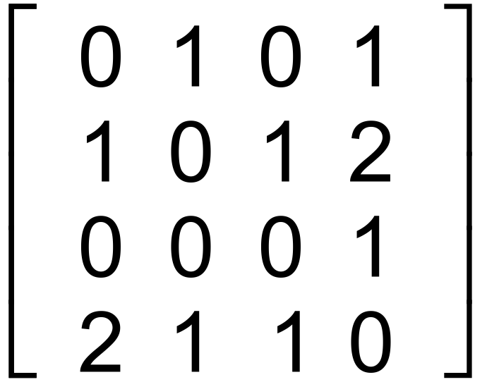

**T** = B

C

D

(a) Draw a network below to represent the information given in Matrix N.

(3 marks)

(b) For matrix **T**

i) Give the matrix **T**2 (1 mark)

ii) Give the value of the element **T**224 and explain what it represents in the context of the

question. (2 marks)

(c) Is it possible to travel from every town to every other town using 3 train trips? (1 mark)

Question 10 (7 marks)

A person who qualifies for a government allowance will be paid $645.90 per fortnight, so long as they do not work. In any fortnight that they do work and earn over $210, their allowance will be reduced by 50 cents in the dollar for earnings over $210.

(a) A student who qualifies for the allowance earns $250 in a fortnight. Calculate the amount of allowance they will receive. (2 marks)

(b) Another student who qualifies for the allowance has a part-time job for 12 hours each week, earning $18.60 per hour. Calculate

(i) their fortnightly wage. (1 mark)

(ii) the amount that the fortnightly allowance is reduced. (2 marks)

(iii) the fortnightly sum of their allowance and wage. (2 marks)

Question 11 (9 marks)

A grocery store has the same brand of instant coffee for sale in three different sized jars.

The 95, 210 and 350 gram jars are priced at $8.20, $17.85 and 31.85 respectively.

(a) Calculate the price per 100 grams for each jar of coffee. (3 marks)

(b) Assuming price is the only consideration, list the jars in order of value, best value first.

(1 mark)

(c) The store is considering stocking a 485 gram jar, priced at $42.30.

(i) Determine how many of the existing jars are better value than this jar. (2 marks)

(ii) Would your answer to (i) change if the price of the 485 g jar was decreased by 3%? Justify your response. (3 marks)

Question 12 (9 marks)

A straight ladder has its foot on level ground and its top resting against a vertical wall. The ladder is 4.65 m long and its foot is 1.80 m away from the bottom of the wall.

(a) Sketch a diagram to show this situation and determine how far up the wall the top of the ladder reaches. (3 marks)

(b) One of the rungs of the ladder is 1.20 m horizontally from the wall and 1.43 m vertically above the ground. Determine how far the rung is from the bottom of the wall. (3 marks)

(c) The foot of the ladder is pushed 45 cm closer to the base of the wall. Calculate how far up the wall the top of the ladder moves. (3 marks)

Question 13 (8 marks)

(a) $23 500 is invested in a 60-day term deposit offering simple interest of 3.15% pa.

Calculate the value of the investment at the end of the 60 days. (3 marks)

(b) A sum of $16 000 is invested at 3.6% per annum for three years.

(i) Determine the value of the investment after three years if the interest is compounded annually. (2 marks)

(ii) Calculate the additional interest earned over three years if the interest is compounded twice a year rather than annually. (3 marks)

Question 14 (8 marks)

An engineering company produces gussets with the shape of the shaded area shown. $ACE$ is a right triangle, $BD$ is an arc of a circle of radius $58$ cm, $AB=16$ cm and $DE=70$ cm.

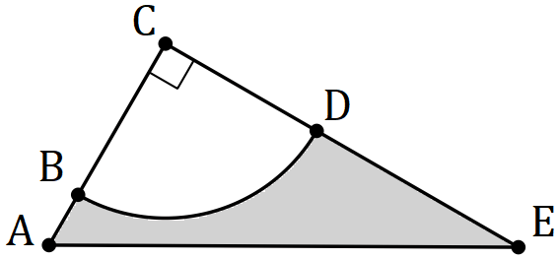

(a) Determine, to the nearest cm, the perimeter of the shaded region. (5 marks)

(b) Determine, to the nearest cm2, the area of the shaded region. (3 marks)

Question 15 (7 marks)

A scale model of a rectangular-based pyramid has a height of 6 cm.

(a) Calculate the scale factor of the model, given that the real pyramid has a height of 18 cm.

(2 marks)

(b) Given that

(i) the length of the diagonal of the base of the scale model is 6.4 cm, calculate the length of the diagonal of the base of the real pyramid. (1 mark)

(ii) the volume of the scale model is 40 cm3, calculate the volume of the real pyramid.

(2 marks)

(iii) the total surface area of the real pyramid is 702 cm2, calculate the total surface area of the scale model. (2 marks)

Question 16 (8 marks)

Solid plastic decorations are made by joining the flat surfaces of two cones together, as shown below. The dimensions of the individual cones are shown in the table.

|  |  |  |  |  |
| --- | --- | --- | --- | --- |
|  | Cone | Radius  (mm) | Slant height (mm) | Perpendicular height (mm) |
| Top | 4.8 | 10.2 | 9.0 |
| Bottom | 4.8 | 19.5 | 18.9 |

(a) Calculate the volume of the top cone. (1 marks)

(b) Determine the total volume of one decoration. (2 marks)

(c) A rectangular prism of plastic, measuring $55×65×100$ mm is to be melted and re-cast into decorations. Assuming there is no wastage, determine the largest number of decorations that can be made. (3 marks)

(d) Calculate the total surface area of one decoration. (2 marks)

Question 17 (8 marks)

A person invested a sum of $48 000 for a period of six months, depositing $24 000 in a simple interest account paying 3.16% pa and using the remainder to buy shares in a technology company for $1.60 each.

(a) Calculate the amount of interest earnt in the deposit account. (3 marks)

(b) Ignoring any costs such as brokerage and so on, determine how many shares the person bought in the company. (1 mark)

During the six months, the company paid the person a dividend of 5.4 cents per share.

(c) Calculate the dividend they received. (1 mark)

(d) At the end of the six months, the person withdrew the principal and interest from the simple interest account and sold the shares for $1.54 each. Calculate the total gain or loss this person made with their investment of $48 000. (3 marks)

Question 18 (9 marks)

The diagram below, on two mm grid paper, shows a scale drawing of the floor plan of four small storage areas in the basement of an apartment block, drawn with a scale of 1 to 50.

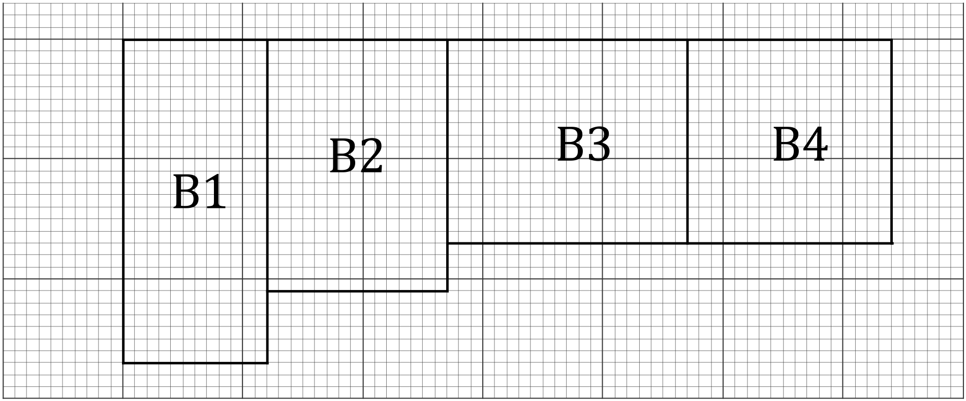

Use dimensions from the scale drawing to answer the following questions about the actual storage areas in the apartment.

(a) Determine the perimeter, in metres, of storage area B2. (3 marks)

(b) Calculate the area, in square metres, of storage area B3. (2 marks)

(c) Apartment owners can rent any of the storage areas at a cost of $28.50 per square metre per month. Determine the cost to rent storage area B1 for a year. (4 marks)

Question 19 (11 marks)

A wine club offers its members Premium ($P$) or Ultimate ($U$) boxes of wine containing a mixture of Red ($R$), White ($W$) or Sparkling ($S$) bottles of wine. The matrix $M$ below shows the number of bottles of each type of wine in each type of box.

$$\begin{matrix} & \begin{matrix}R & W & S\end{matrix} \\ \begin{matrix}P \\ U\end{matrix} & \left[\begin{matrix}5 & 4 & 3 \\ 2 & 6 & 4\end{matrix}\right]\end{matrix}$$

The club purchases the bottles of wine from a wholesaler who charges them $19.50, $22.50 and $27.50 for one bottle of red, white and sparkling wine respectively.

(a) Write the cost of a bottle of red, white and sparkling wine, in that order, in column matrix $A$. (1 mark)

(b) Use your calculator to multiply matrices $M$ and $A$ together to obtain matrix $B$. (2 marks)

(c) Explain what information matrix $B$ represents. (1 mark)

(d) The club has orders for 195 Premium and 85 Ultimate boxes.

(i) Write these numbers in matrix $C$, so that $C×M$ shows the number of bottles of each type of wine required to meet the orders and evaluate $C×M$. (2 marks)

(ii) Show use of a matrix method to determine the total cost of buying the bottles of wine to meet the orders for 195 Premium and 85 Ultimate boxes. (3 marks)

(e) The club makes a profit of 9% and 15% on each Premium and Ultimate box respectively. Square matrix $D$ can be multiplied by matrix $B$ to calculate the selling price for each type of box. Write down matrix $D$. (2 marks)

Supplementary page

Question number: _________

Supplementary page

Question number: _________

Supplementary page

Question number: _________

Supplementary page

Question number: _________